Project Title: Team ID:

Analytics for Hospitals' Health-Care Data **Project Design Phase-I** - **Solution Fit Template** PNT2022TMID07365

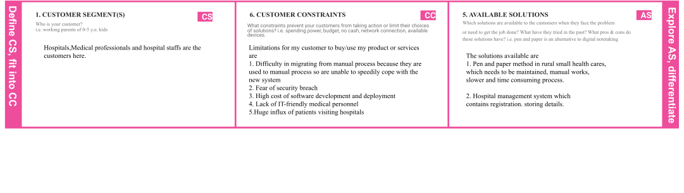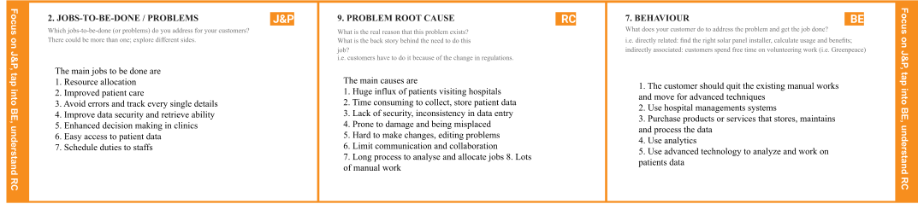

|  |  |  |  |  |  |  |
| --- | --- | --- | --- | --- | --- | --- |
|  | **3. TRIGGERS**  What triggers customers to act? i.e. seeing their neighbour installing solar panels, reading about a more efficient solution in the news.  The triggers for my customers are   1. Facing the existing challenges, and difficulties 2. Looking at other sectors growing 3. Advancements and growth in technology 4. Increased productivity from hospital managementsystem 5. Increased analytics work | **TR** | **10. YOUR SOLUTION SL**  If you are working on an existing business, write down your current solution first, fill in the canvas, and check how much it fits reality.  If you are working on a new business proposition, then keep it blank until you fill in the canvas and come up with a solution that fits within customer limitations, solves a problem and matches customer behaviour.  The answer is to accurately predict the Length of Stay(LOS) for each patient on case by case basis so that the Hospitals can use this information for optimal resource allocation and better functioning. This parameter helps hospitals to identify patients of high LOS risk at the time of admission. Once identified, patients with high LOS risk can optimise their treatment plan to minimize LOS and lower the chance of staff/visitor infection. Also, prior knowledge of LOS can aid in logistics such as room and bed allocation planning. An informative, creative dashboard can be created to present the data and utilize it for prior proper planning and resource allocation. | 1. **CHANNELS of BEHAVIOUR**    1. **ONLINE**   What kind of actions do customers take online? Extract online channels from #7   * 1. **OFFLINE**   What kind of actions do customers take offline? Extract offline channels from #7 and use them for customer development   * 1. ONLINE   Customers can purchase the service/product and use it to store patients data regularly, maintain their details, create dashboards and work on it online efficiently and effectively   * 1. OFFLINE   By Using the collected data, customers can interpret, analyze, and utilize the data to allocate resources, schedule jobs to staffs, do planning for proper management of hospital  . | **CH** |  |

|  |  |  |  |  |
| --- | --- | --- | --- | --- |
|  | **4. EMOTIONS: BEFORE / AFTER EM**  How do customers feel when they face a problem or a job and afterwards?  i.e. lost, insecure > confident, in control - use it in your communication strategy & design.  Before   1. Frustrated, confused 2. Inefficient time management 3. Poor resource allocation, staffing 4. Worried about huge stuff of work, workload 5. Work pressure   After   1. Secured, find it easy, efficient and reliable 2. Efficient time management 3. Better resource allocation 4. Less manual work 5. Need to develop technical knowledge |  |  |  |